|  |  |
| --- | --- |
| **Lab 1** | |
| **Name** | Dang Hoang Nguyen |
| **Student ID** | SE160196 |

**1. How has the OWASP Top 10 evolved over the past few years, and what are the key differences in the most recent versions compared to earlier ones?**

**The Evolving Landscape of Web Application Security: A Look at the OWASP Top 10**

The OWASP Top 10, developed by the Open Web Application Security Project (OWASP), is a widely recognized and influential list of the most critical web application security risks. This dynamic document continuously evolves to reflect the ever-changing threat landscape and emerging vulnerabilities. Let's delve into the evolution of the OWASP Top 10 over the past few years, highlighting key differences between recent and earlier versions.

**From 2013 to 2017:**

* **Focus on Prevalence:** The earlier versions, like the 2013 and 2017 editions, were heavily influenced by data on the incidence of vulnerabilities. This resulted in a list dominated by injection flaws like SQL injection (SQLi) and cross-site scripting (XSS).
* **Static Categories:** The categories remained relatively static over these years, with some minor name changes and reordering.

**The 2021 Update**

The 2021 update marked a significant shift in the OWASP Top 10's approach. Here are some key changes:

* **Strategic Focus:** The emphasis moved from mere prevalence to a more strategic perspective, considering exploitability, potential impact, and root causes. This led to the introduction of new categories like "Insecure Design" and "Security Misconfiguration."
* **Consolidation and Expansion:** Some categories were consolidated (e.g., "Broken Authentication" merging with "Identification and Authentication Failures"), while others were broadened in scope (e.g., "Sensitive Data Exposure" now encompassing a wider range of data risks).
* **New Threats, New Concerns:** The 2021 list introduced three entirely new categories reflecting emerging threats: "Security Logging and Monitoring Failures," "API Security," and "Software Supply Chain Security."

**Beyond 2021:**

The OWASP Top 10 is a living document, constantly adapting to the evolving security landscape. We can expect future iterations to address new attack vectors, emerging technologies, and the ever-changing tactics of malicious actors.

**Key Takeaways:**

* The OWASP Top 10 has shifted from a purely incidence-based ranking to a more strategic focus on exploitability, impact, and root causes.
* The 2021 update saw significant changes, including category consolidation, expansion, and the introduction of entirely new categories addressing emerging threats.
* The OWASP Top 10 remains a valuable resource for developers, security professionals, and anyone concerned with web application security.

## 2. What are the common factors that lead to vulnerabilities moving up in rank within the OWASP Top 10 list? Are there specific trends or technologies that contribute to this change?

Several factors can contribute to a vulnerability's ascent in the OWASP Top 10 rankings, often reflecting evolving trends and technologies within the web application security landscape. Here are some key drivers:

**Increased Prevalence and Exploitability:**

* **Exploit Kits and Automation:** The rise of readily available exploit kits and automated attack tools simplifies exploiting certain vulnerabilities, making them more attractive to attackers and increasing their potential impact. For example, the surge of SQL injection attacks in the early 2010s was partly fueled by readily available SQLi exploit kits.

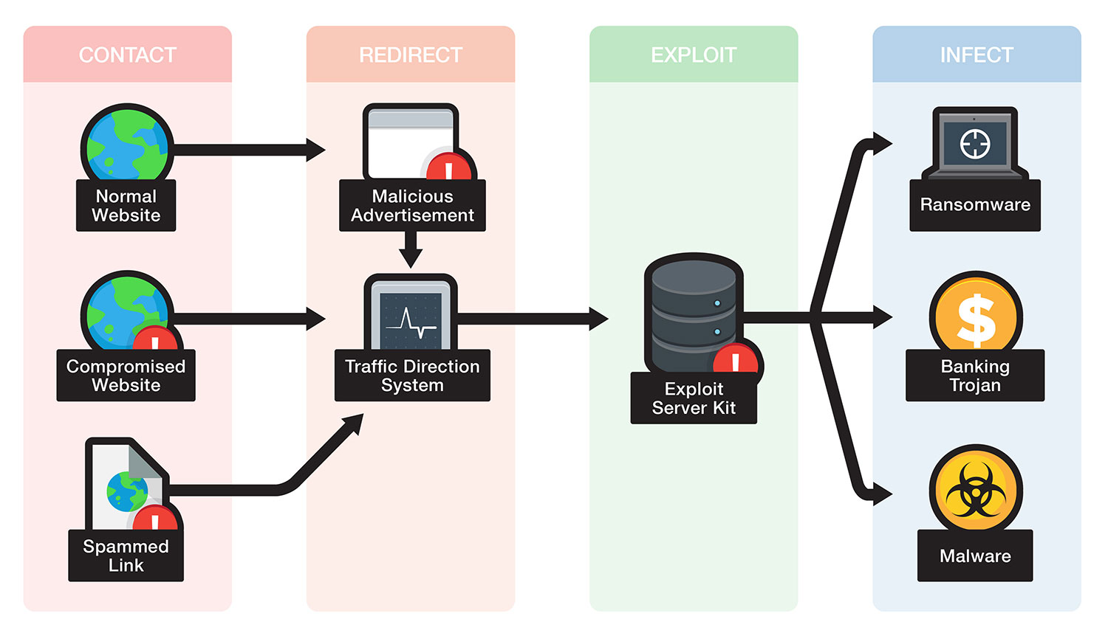

SQL injection exploit kit

* **Widespread Adoption of Specific Technologies:** Vulnerabilities affecting widely used technologies or libraries tend to climb the OWASP Top 10 due to their broader attack surface and potential impact on a larger user base. For instance, the prominence of JavaScript vulnerabilities in recent years reflects the ubiquity of JavaScript in modern web applications.

**Shifting Threat Landscape and Attacker Motivations:**

* **Evolving Attacker Tactics:** Attackers constantly adapt their approaches, targeting new vulnerabilities and exploiting weaknesses in existing security controls. This can lead to vulnerabilities previously considered less critical moving up the rankings as they become more actively exploited. For example, the rise of API security concerns in recent years reflects the growing attack focus on APIs as a potential entry point to sensitive data.



API security threats

* **Data-Driven Attacks:** As attackers increasingly prioritize financial gain and data theft, vulnerabilities enabling data breaches or unauthorized access to sensitive information tend to become more critical. This trend is reflected in the prominence of categories like "Sensitive Data Exposure" and "Identification and Authentication Failures" in the OWASP Top 10.

**Changes in Security Practices and Awareness:**

* **Improved Detection and Reporting:** Enhanced security tools and vulnerability scanners may uncover previously undetected vulnerabilities, leading to their inclusion in the OWASP Top 10. Additionally, increased awareness and reporting of certain vulnerabilities can contribute to their higher ranking.

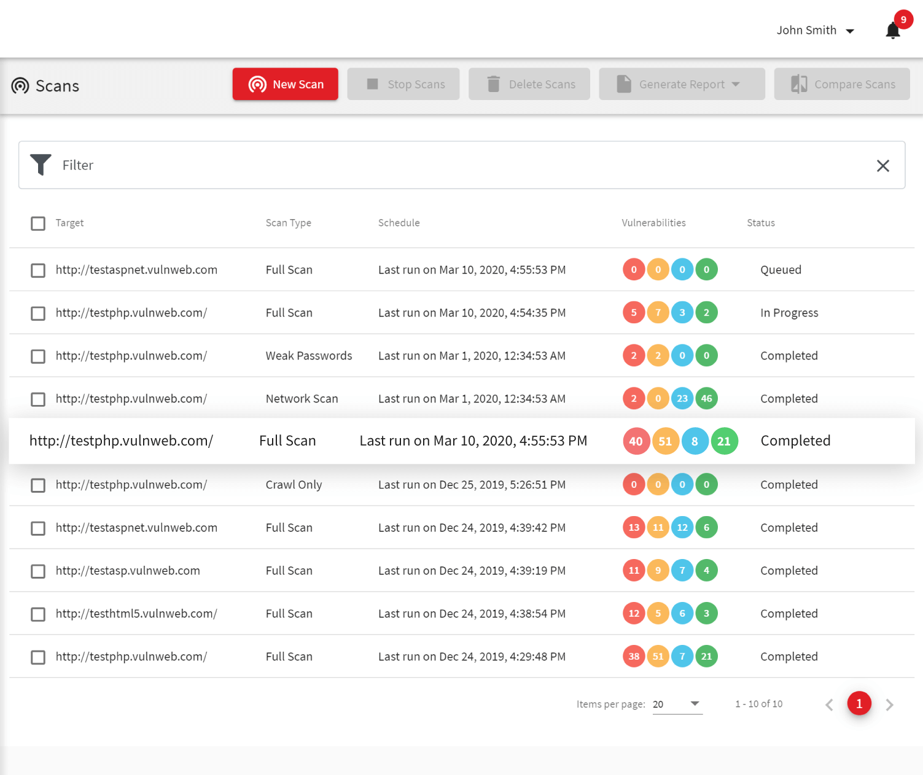

Acunetix web scanner

* **Security Misconfigurations and Patching Lag:** Vulnerabilities stemming from misconfigured systems or outdated software often remain unpatched for extended periods, increasing their exposure and potential impact. This highlights the importance of proper configuration management and timely patching practices.

**3. Can you identify real-world examples of data breaches or security incidents that were caused by vulnerabilities listed in the OWASP Top 10? What were the consequences, and how could these incidents have been prevented?**

The OWASP Top 10 serves as a valuable roadmap for understanding and addressing the most critical web application security risks. Real-world incidents, unfortunately, provide stark reminders of the potential consequences of neglecting these vulnerabilities.

**1. Injection Flaws:**

* **Vulnerability:** SQL injection (SQLi) and cross-site scripting (XSS) remain prevalent threats, allowing attackers to inject malicious code into applications and gain unauthorized access or control.
* **Example:** In 2013, the popular social media platform LinkedIn suffered a major data breach due to an SQLi vulnerability. Attackers gained access to millions of user emails and passwords, highlighting the severe consequences of injection flaws.
* **Prevention:** Proper data validation and input sanitization, using prepared statements for database interactions, and regularly updating software to patch known vulnerabilities are crucial in mitigating injection risks.

**2. Broken Authentication:**

* **Vulnerability:** Weak authentication mechanisms, such as insecure password hashing or predictable user IDs, can be exploited to gain unauthorized access to accounts and sensitive data.
* **Example:** In 2017, Yahoo experienced a massive data breach affecting over 3 billion user accounts. Attackers exploited a combination of vulnerabilities, including weak password hashing and social engineering, to steal user data and access internal systems.
* **Prevention:** Implementing strong password hashing algorithms (e.g., bcrypt), enabling multi-factor authentication, and enforcing secure user account management practices can significantly improve authentication security.

**3. Sensitive Data Exposure:**

* **Vulnerability:** Inadequate data protection measures, such as unencrypted storage or transmission of sensitive information, can expose user data like passwords, financial information, or personally identifiable information (PII) to unauthorized access.
* **Example:** In 2018, British Airways faced a £183 million fine due to a data breach where attackers exploited a vulnerability in their online booking system to steal the credit card information of over 500,000 customers.
* **Prevention:** Encrypting sensitive data at rest and in transit, implementing access control mechanisms, and regularly assessing and addressing potential data exposure risks are crucial for protecting sensitive information.

**4. Security Misconfiguration:**

* **Vulnerability:** Improperly configured systems, outdated software, or misconfigured security settings can create exploitable vulnerabilities even in applications with otherwise sound security practices.
* **Example:** In 2020, the popular video conferencing platform Zoom faced criticism for security vulnerabilities exposed due to misconfigured servers and security features. Attackers could potentially gain access to meetings and sensitive user data.
* **Prevention:** Regularly reviewing and updating system configurations, following security best practices, and patching software promptly are essential in preventing security misconfiguration vulnerabilities.

## 4. Are there regional or industry-specific variations in the prevalence of vulnerabilities listed in the OWASP Top 10? How do these variations impact security practices and strategies?

The OWASP Top 10, while offering a valuable global perspective on web application security risks, doesn't account for regional or industry-specific nuances. These variations can significantly impact the prevalence and criticality of certain vulnerabilities, shaping security practices and strategies accordingly.

**Regional Variations:**

* **Geopolitical Landscape:** Regions with heightened cybercrime activity or specific government regulations might experience a higher prevalence of certain vulnerabilities targeted by state-sponsored actors or compliance requirements. For example, regions with stricter data privacy regulations might prioritize data exposure vulnerabilities more than others.
* **Technology Adoption Rates:** The adoption rates of specific technologies and software can vary across regions. This can influence the vulnerability landscape, as certain regions might be more susceptible to vulnerabilities in widely used local software not prevalent globally.
* **Security Awareness and Maturity:** Differences in security awareness and maturity levels among regions can impact the prevalence and exploitation of vulnerabilities. Regions with less mature security practices might be more vulnerable to common attacks exploiting well-known flaws.

**Industry-Specific Variations:**

* **Data Assets and Sensitivities:** Industries handling sensitive data like healthcare or finance might prioritize vulnerabilities related to data exposure and authorization more than others. Conversely, industries dealing with less sensitive data might focus more on availability-related vulnerabilities impacting service uptime.
* **Attacker Motivations and Targets:** Different industries attract attackers with specific motivations. For example, e-commerce platforms might be targeted for credit card information theft, while government websites might be targeted for espionage or disruption. This can influence the types of vulnerabilities attackers prioritize.
* **Regulatory Compliance:** Industry-specific regulations can dictate additional security requirements, influencing the focus and prioritization of vulnerabilities within an industry. For instance, financial institutions might have stricter regulations regarding encryption and authentication, impacting their vulnerability landscape.

**Impact on Security Practices and Strategies:**

Understanding regional and industry-specific variations in vulnerabilities is crucial for tailoring security practices and strategies effectively. Here's how these variations can impact:

* **Vulnerability Assessments and Penetration Testing:** Organizations should prioritize vulnerabilities relevant to their region and industry during security assessments and penetration testing.
* **Security Awareness Training:** Security awareness training should be tailored to address the specific threats and vulnerabilities relevant to the organization's region and industry.
* **Resource Allocation and Investment:** Organizations can allocate security resources and investments to address the most critical vulnerabilities based on their regional and industry context.

## 5. What are the most effective strategies and best practices for developers and organizations to proactively address and mitigate the vulnerabilities outlined in the OWASP Top 10?

The OWASP Top 10 serves as a roadmap for addressing critical web application security risks. But proactively mitigating these vulnerabilities requires more than just awareness. Here are some effective strategies and best practices for developers and organizations to implement:

**Development Phase:**

* **Secure Coding Practices:** Embed security into the development process from the start. Train developers on secure coding principles, utilize static and dynamic code analysis tools, and leverage libraries and frameworks with strong security track records.
* **Threat Modeling:** Identify potential vulnerabilities early in the development cycle by employing threat modeling techniques. This helps anticipate how attackers might target your application and prioritize mitigation efforts.
* **Input Validation and Sanitization:** Validate and sanitize all user input to prevent code injection and other manipulation vulnerabilities. Use established libraries and frameworks with built-in validation functions to avoid common pitfalls.
* **Secure Design Principles:** Implement security principles like least privilege, separation of concerns, and secure defaults throughout the application design and architecture. This minimizes the attack surface and reduces the potential impact of vulnerabilities.

**Deployment and Maintenance Phase:**

* **Secure Configuration:** Follow secure configuration best practices for all infrastructure and application components. Harden servers, patch software promptly, and disable unnecessary features or functionalities.
* **Access Control and Authentication:** Implement robust access control mechanisms and strong authentication protocols like multi-factor authentication to prevent unauthorized access and credential theft.
* **Regular Security Testing:** Conduct penetration testing and vulnerability assessments regularly to identify and address existing vulnerabilities before attackers exploit them. Utilize automated tools alongside manual testing for comprehensive coverage.
* **Security Monitoring and Logging:** Implement centralized security monitoring and logging systems to detect suspicious activity and potential breaches in real-time. Analyze logs regularly and respond promptly to identified threats.
* **Incident Response Planning and Training:** Prepare for security incidents with a well-defined incident response plan and train your team to handle them effectively. Conduct regular drills and simulations to test your plan and identify areas for improvement.

**Organizational Culture and Governance:**

* **Security Awareness Training:** Foster a security-aware culture by providing regular security awareness training to your developers and non-technical staff. Educate everyone on the importance of security and best practices for handling sensitive data.
* **DevSecOps Integration:** Break down silos between development and security teams and embrace DevSecOps practices. Integrate security considerations throughout the entire software development lifecycle to ensure security is not an afterthought.
* **Continuous Improvement:** Continuously update your security practices and procedures based on the latest threats, vulnerabilities, and industry best practices. Stay informed about emerging trends and adapt your strategies accordingly.